Backchannels in the Classroom
A backchannel can be defined as a group of people using computers or smartphones to have a real-time online conversation alongside a live spoken conversation.

Why use a backchannel in the classroom?
21st Century skills and the Common Core Learning Standards (CCLS) expect that we prepare our children to communicate, collaborate, and connect to each other, but also to find and share information.

Using a private chatroom as the platform to practice all the above mentioned skills is a means to harness the students’ excitement for use of technology and chatting as a means of communication to receive material previously discussed in class and collaboratively compile and organize information during class.

Communicating clearly on the Internet without creating misunderstandings is a challenge. One problem is that you haven’t any facial expressions, body language, or environment to help you express yourself; another that there is little “give and take” for developing what you mean to say or are discussing. It is important to practice digital citizenship when communicating on a backchannel. Use these guidelines to help you:
- Be clear
- Use Appropriate Language
- Be brief (you only have 140 characters)
- Make a good impression
- Think before you post
- Remember you are not anonymous – but you are public - First names only!
- Be selective on what information you share
- Consider others
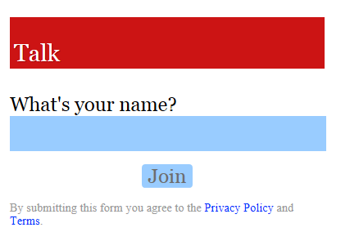
- Find our backchannel for today at
_______INSERT YOUR LINK______________
- Enter your first name (no fake names) in the “Who are you” box
- Press tab or click the “What do you want to say” box to type in an opening welcome message
- You can address your colleagues by stating “@username”
- Throughout our session today, we will be using this backchannel to post comments, thinking process, reflection, questions, and suggestions

