All SLOs MUST include the following basic components:
Student  Population | These are the students assigned to the course section(s) in this SLO - all students who are assigned to the course section(s) must be included in the SLO. (Full class rosters of all students must be provided for all included course sections.)  Course: Grade K ELA Teacher: ABCD 20 students
Learning Content | What is being taught over the instructional period covered? Common Core/National/State standards? Will this goal apply to all standards applicable to a course or just to specific priority standards?  Source of Standards: Common Core Learning Standards – with a focus on the Reading Foundational Strand  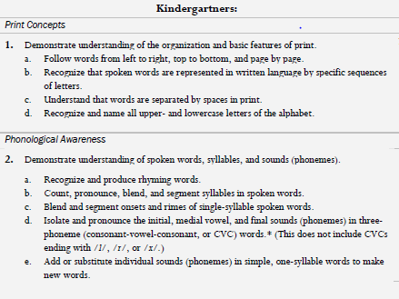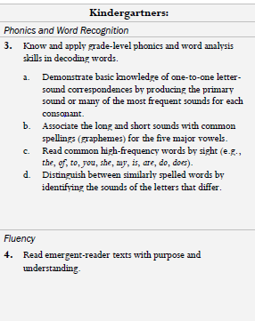
Interval of Instructional Time | What is the instructional period covered (if not a year, rationale for semester/quarter/etc)?  One year (September 24, 2012 – May 31, 2013
Evidence | What specific assessment(s) will be used to measure this goal? The assessment must align to the learning content of the course.  Pre-Assessment: AIMSweb Summative Assessment: AIMSweb  Offers accommodations as legally require and appropriate for IEPs and 504 plans  AIMSweb software does the scoring and computation; therefore, ensures that those with vested interest are not scoring summative assessments
Baseline | What is the starting level of students’ knowledge of the learning content at the beginning of the instructional period?  Student # Performance Summary Pre-Assessment  Well above average 48  Well above average 36  Well above average 35  Above Average 32  Above Average 29  Above Average 28  Average 26  Average 26  Average 22  Average 18  Average 16  Average 15  Average 14  Average 14  Average 12  Below Average 7  Below Average 5  Well below Average 3  Well below Average 2  Well below Average 2
Target(s) | What is the expected outcome (target) of students’ level of knowledge of the learning content at the end of the instructional period?  (See roster, pre-test score, and calculation formula “Early Literacy Norm-Referenced Chart” and target score at end of template)  80% of students, including special education populations will grow based on early literacy norm-referenced calculation which is the SLA score + (.9 LNC rating*36 weeks) to meet or exceed target goal.
HEDI Scoring | How will evaluators determine what range of student performance “meets” the goal (effective) versus “well-below” (ineffective), “below” (developing), and “well-above” (highly effective)?  High Effective = 90% of students or more will meet or exceed their target goal on the summative assessment.  Effective = 72%-89% of students will meet or exceed their target goal on the summative assessment.  Development = 60%-70% of students will meet or exceed their target goal on the summative assessment  Ineffective = 50-0% of students or fewer will meet or exceed their target goal on the summative assessment
 | HIGHLY EFFECTIVE |  |  | EFFECTIVE |  |  |  |  |  |  |  |  | DEVELOPING |  |  |  |  |  | INEFFECTIVE
 | 20 | 19 | 18 | 17 | 16 | 15 | 14 | 13 | 12 | 11 | 10 | 9 | 8 | 7 | 6 | 5 | 4 | 3 | 2 | 1 | 0
 | 96-100% | 93-95% | 90-92% | 88-89% | 86-87% | 84-85% | 82-83% | 80-81% | 79-78% | 77-76% | 75-74% | 72-73% | 71-70% | 69-68% | 67-66% | 65-64% | 63-62% | 61-60% | 59-50% | 49-30% | 29-0%
Rationale | Describe the reasoning behind the choices regarding learning content, evidence, and target and how they will be used together to prepare students for future growth and development in subsequent grades/courses, as well as college and career readiness.

Grant Elementary School Teacher: ABCD School Year 2012-2013
Grade K AIMSweb - Letter Naming Fluency
Student # | Pre-Assessment | Target Goal
 | 48 | 80
 | 36 | 68
 | 35 | 67
 | 32 | 64
 | 29 | 61
 | 28 | 60
 | 26 | 58
 | 26 | 58
 | 22 | 54
 | 18 | 50
 | 16 | 48
 | 15 | 47
 | 14 | 46
 | 14 | 46
 | 12 | 44
 | 7 | 39
 | 5 | 37
 | 3 | 35
 | 2 | 34
 | 2 | 34

Grant Elementary School Teacher:ABCD School Year 2012-2013
Grade K AIMSweb - Letter Naming Fluency
Student # | Performance Summary | Pre-Assessment  SLA score + | Compute  (.9 * 36) | Target Goal
 | Well above average | 48 | 32.4 | 80
 | Well above average | 36 | 32.4 | 68
 | Well above average | 35 | 32.4 | 67
 | Above Average | 32 | 32.4 | 64
 | Above Average | 29 | 32.4 | 61
 | Above Average | 28 | 32.4 | 60
 | Average | 26 | 32.4 | 58
 | Average | 26 | 32.4 | 58
 | Average | 22 | 32.4 | 54
 | Average | 18 | 32.4 | 50
 | Average | 16 | 32.4 | 48
 | Average | 15 | 32.4 | 47
 | Average | 14 | 32.4 | 46
 | Average | 14 | 32.4 | 46
 | Average | 12 | 32.4 | 44
 | Below Average | 7 | 32.4 | 39
 | Below Average | 5 | 32.4 | 37
 | Well below Average | 3 | 32.4 | 35
 | Well below Average | 2 | 32.4 | 34
 | Well below Average | 2 | 32.4 | 34

This text is cited from AIMSweb progress monitoring pdf

Establishing Learning Goals
To write the annual goal for a student using the information gained from AIMSweb, you will need the following information:
- Number correct score from the SLA probe for the grade level that will be used
for progress monitoring

- Anticipated growth rate

- The growth rate for a typical student at each grade level on every measure can
be found on the Norm Referenced Charts for SLA Placement. In order for
your student to remain where they are in reference to their peers, they need to
grow at the rate listed. To make gains, they need to grow at a faster rate. The
number you use for the anticipated growth rate will be based upon your
professional judgment and the intensities of the interventions provided.

- The number of weeks you plan to monitor the goal (52 weeks for an IEP goal)

- You will be able to use the charts provided by AIMSweb to track the students
- progress towards the goal over the course of the year.

Use this formula to calculate your goal:
Goal = SLA score + (anticipated growth rate * number of weeks)

Example:
For a fourth grade student that earned an SLA score of 38 words read correct
(WRC) on the second grade R-CBM measure and you anticipate her to gain 1.5
WRC per week over the next year, her annual goal would be to read 116 WRC on
an AIMSweb second grade passage at her fifth grade IEP meeting.

116 Annual goal for WRC = 38 + (1.5 * 52)

Practice with Grade K Student #1 on Roster:

Goal = 48 + (.9 * 36)

Goal = 80.4

Early Literacy Norm Referenced Charts for SLA Placement
