Setting Learning Targets
Before you begin to set targets you must know the following:
- District decisions regarding types of targets that the district will allow
- District decisions regarding rigor of targets that must be set
- Your baseline data/sources of evidence

What is a Target?
In simplest terms, a target is the expected outcome for the students by the end of the instructional period. It must be numeric and represent at least a year’s worth of growth.
There are two types of targets:
- Growth Target: Written to demonstrate an increase in levels or points between the pre- and post-assessments.
Example: 80% of all students, including special populations, will grow by 40 points or more on the summative assessment.

- Mastery Target: Written to demonstrate growth to a static score that is pre-established by the district.
Example: 80% of all students, including special populations, will grow to 75% or higher on the summative assessment.

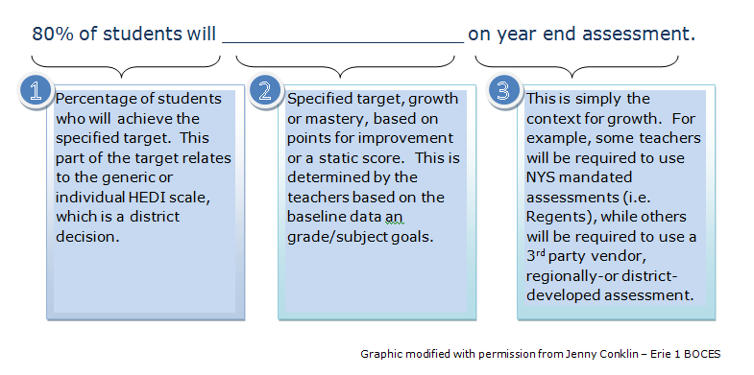
A target has three components:

Differentiating Targets
Targets may be differentiated to meet the needs of a diverse student population. Any differentiation of targets should also have a rationale provided on the SLO template.
Targets may be differentiated as follows:

Write your target each of three ways to find the “right fit”:

Some Guidelines for Setting Quality Targets
- Targets should be consistent with district expectations regarding rigor.
- When possible, targets should be set using multiple measures.
- Regulations require that students must demonstrate at least one year’s growth; for students already below grade level, growth must be more than one year.
- NYSED has defined a “rigorous” goal as one that asks for 80% or more of students to meet the target.

